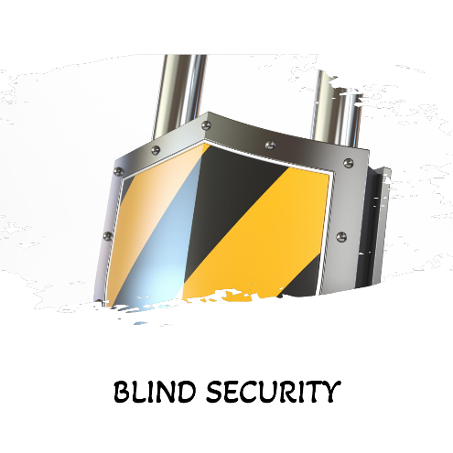

**Statement of Work**

|  |  |
| --- | --- |
| **Blind Security (“Customer”)** | **CSCGR Pentesting Team (“Supplier”)** |
| Kaykasou 19, Aristotelous | Athens University of West Attica |
| 54044 Thessaloniki | 122 43 |
| Greece | Greece |
|  |  |
| Email: [accounts@blindsecurity.net](mailto:accounts@blindsecurity.net) | Email: [your@team.email](mailto:your@team.email) |
| Telephone: 240765432 |  |
| VAT: 589552658 | VAT: N/A |
|  |  |
| Contact: Petros Papadopoulos | Contact: Your-Team-Lead-Name |

## Introduction

|  |
| --- |
| **Name of Project** |
| *ID-54126 – Forensics Consulting Support* |

|  |
| --- |
| **Agreement Description** |
| *Under this Statement, the Customer entrusts the performance of the following activity to the Supplier (hereinafter referred to as the “Services”):*   1. *Forensics analysis of retrieved artifacts* |

|  |
| --- |
| **Execution Dates** |
| *Consulting Support is planned to commence on 28th of March 2025 at 13:30 Athens time, and completed on 28th of March 2025 at 19:30 Athens time.* |

## Location

The work can be performed from either Athen’s main event location (University of West Attica), Thessaloniki’s hub location (University of Macedonia), Patra’s hub location (University of Peloponnese), Samos’ hub location (University of Aegean), or remote. The durations are as shown below:

|  |  |
| --- | --- |
| **Site** | **Duration** |
| Office Locations | 6 hours |
| Remote Location | 6 hours |

## Deliverables

|  |  |  |
| --- | --- | --- |
| **Deliverable** | **Objective** | **Due Date** |
| List of flags/Answers | Flags and amount of flags captured | 28/03/2025, 19:30 Athens Time |
| Results Report | TXT document outlining the attack chain identified and educated guesses on the attackers’ plans. | 28/03/2025, 19:30 Athens Time |

## Resources

|  |  |  |
| --- | --- | --- |
| **Consultant Name** | **Role** | **Level** |
| Your-Team-Lead name | Project Manager | Senior Consultant |
| Team-Member | Fieldwork Execution | Consultant |
| Team-Member | Fieldwork Execution | Consultant |
| Team-Member | Fieldwork Execution | Consultant |

## Renumeration

Supplier will invoice for the Work on time and material basis. The Supplier will charge a flat blend rate of €**100** per consultant.

The total fees payable of this Statement is estimated at maximum €**2400**, excluding VAT.

## Invoicing

Invoices shall be addressed to: **Blind Security VAT: 589552658**

Invoices shall make reference to: **ID-54126 – Forensics Consulting Support**

|  |  |
| --- | --- |
| For and behalf of  **Blind Security** | For and behalf of  **Your-Team-Name** |
| __________________________________ | ___________________________________ |
| Petros Papadopoulos | Your-Name |
| CSO | Your-Title |
| Date: 28-03-2025 | Date: 28-03-2025 |